**Session 1 Assignment 2**

1. **PWD:**

PWD prints the full pathname of the current working directory.

**Command:** [acadgild@localhost -]$ /bin/pwd

**Output:** /home/acadgild

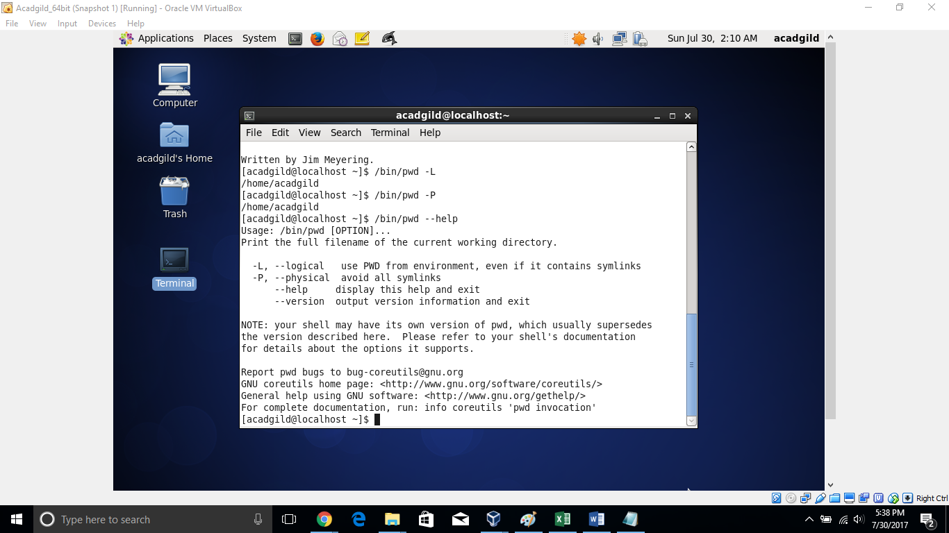

1. **Vi editor:**

Vi is a command line Text Editor.

There are two modes in Vi. Insert (or Input) mode and Command mode.

Input mode: Enter content to the file.

Command mode (Edit mode): Many commands to edit content by insert, append or delete etc.

**Command**: [acadgild@localhost -]$ vi test -- here test is the text file name

**Output**: opens text editor. If file doesn’t exists it creates new file with that name. Perform operations insert or edit.

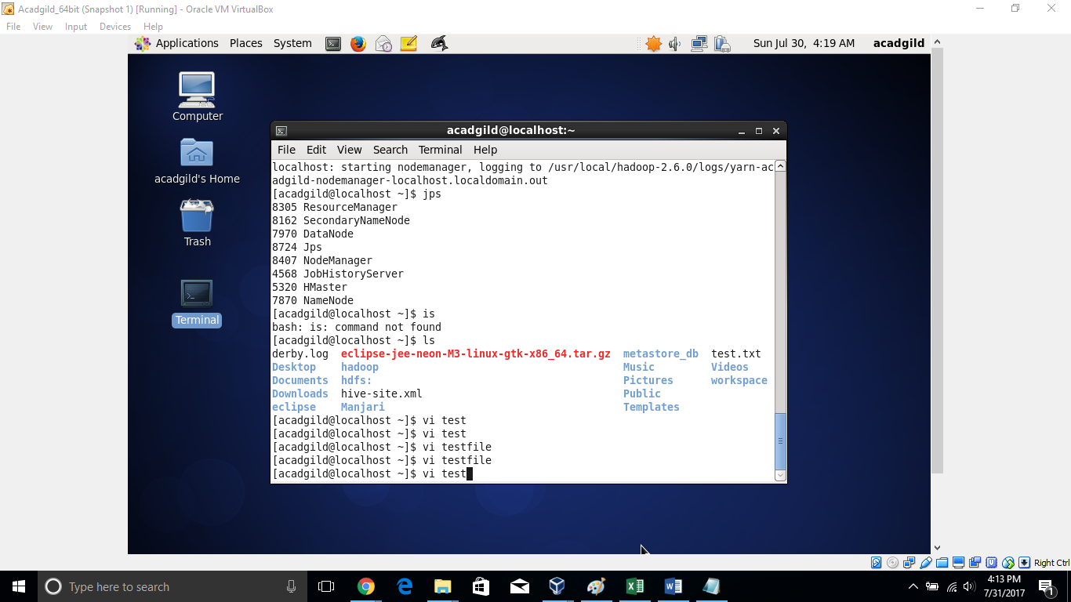

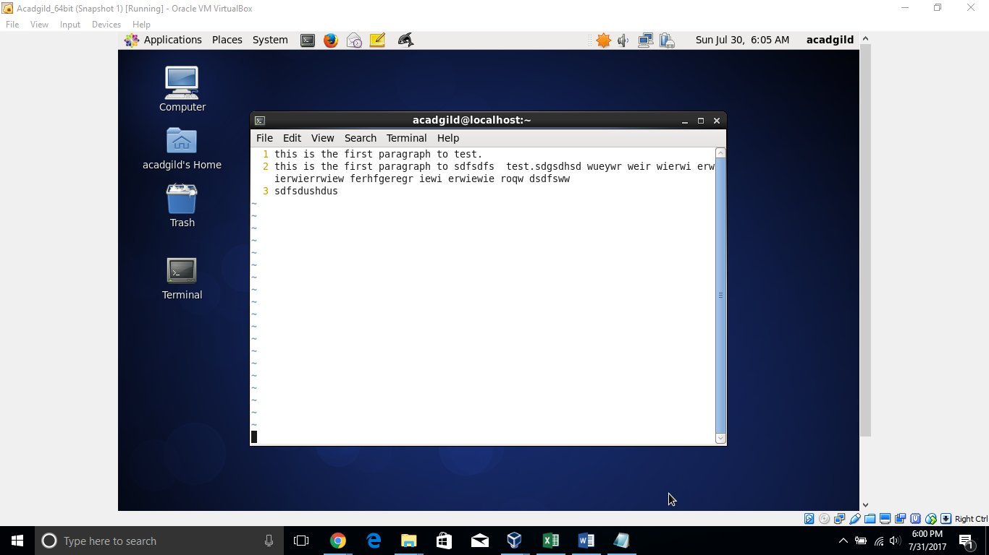

1. **touch**

The touch command creates an empty file and updates the access and modification times of files.

Command: [acadgild@localhost -]$ stat test2

Output: displayed file accessed, modified and changed timestamp details.

Command: [acadgild@localhost -]$ touch test2 - - if file exists it changes time stamp to current timestamp

Output: displayed changes details with new timestamp.

Command: [acadgild@localhost -]$ stat test2

Below screen explains how file ‘test2’ timestamp changed.

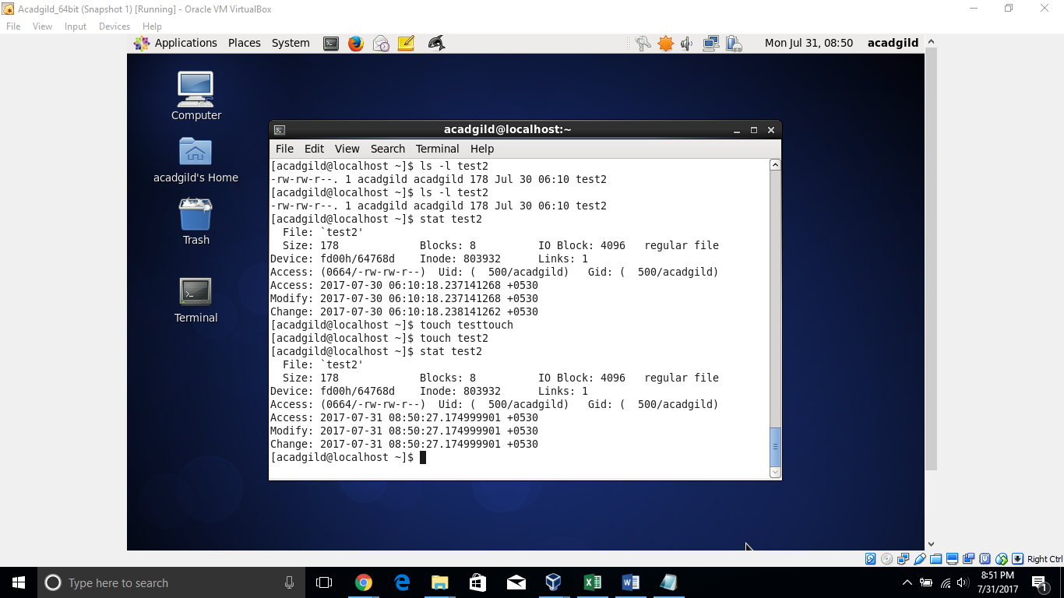

1. **mkdir:** make new directory.

Command: [acadgild@localhost -]$ mkdir –m 755 –v testdir2

Output: create directory testdir2 with mentioned permissions and displays a message.

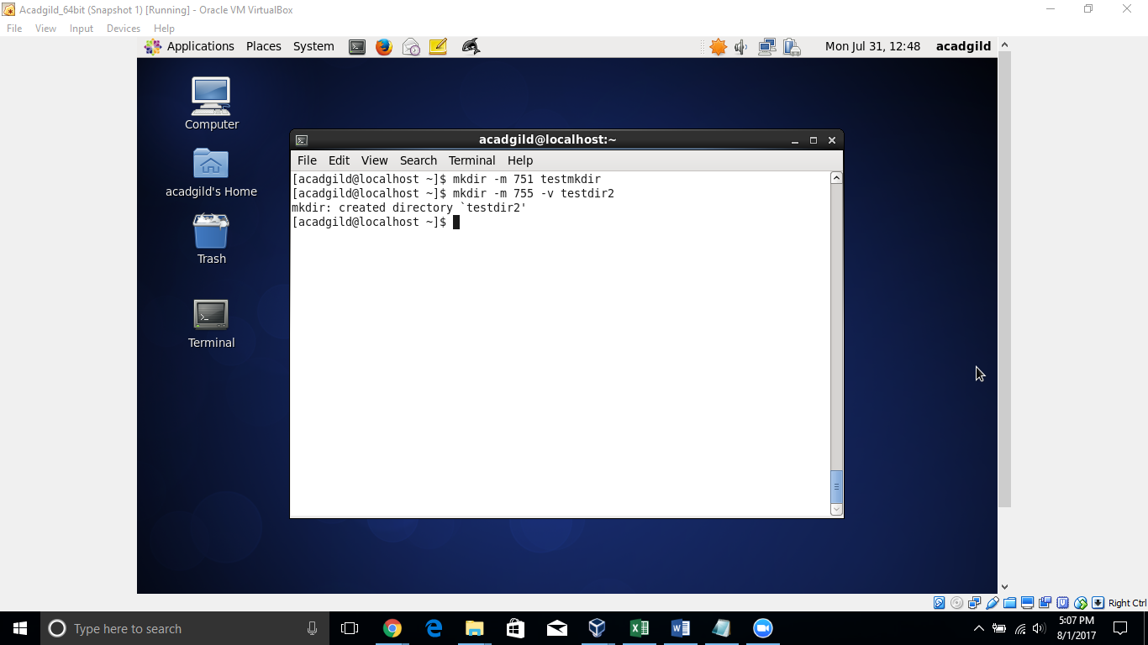

1. **rm:** remove files or directories

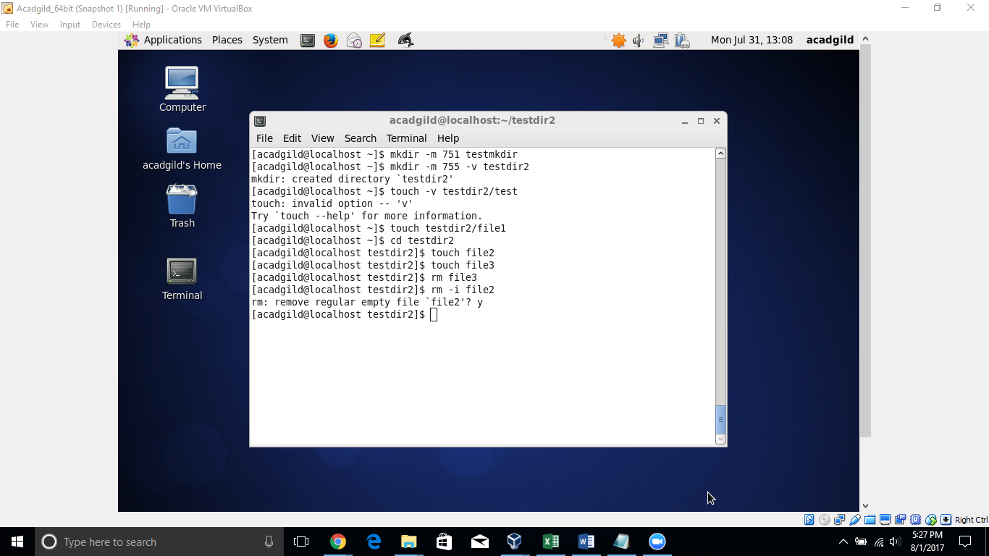

1. **ls:** lists files and directories

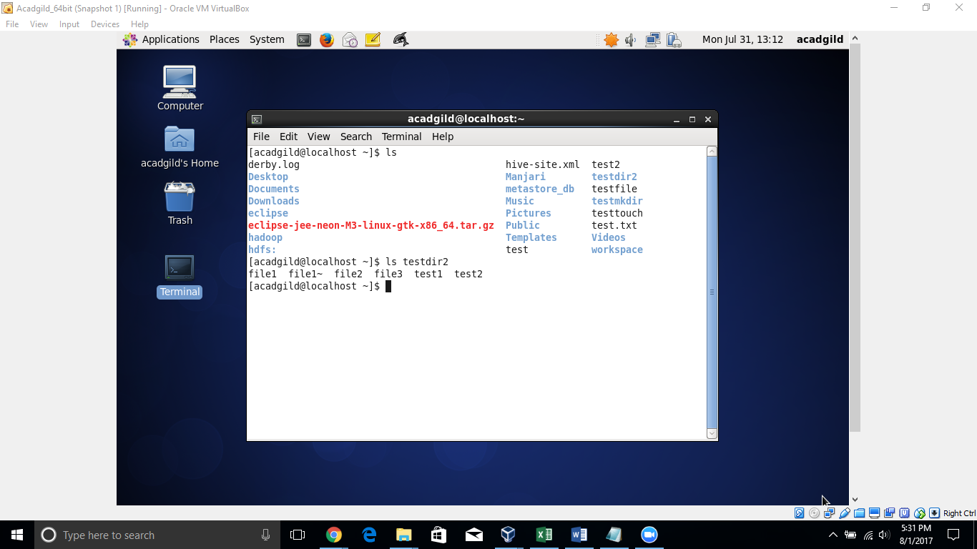

1. **echo:** display a line of text/string on standard output

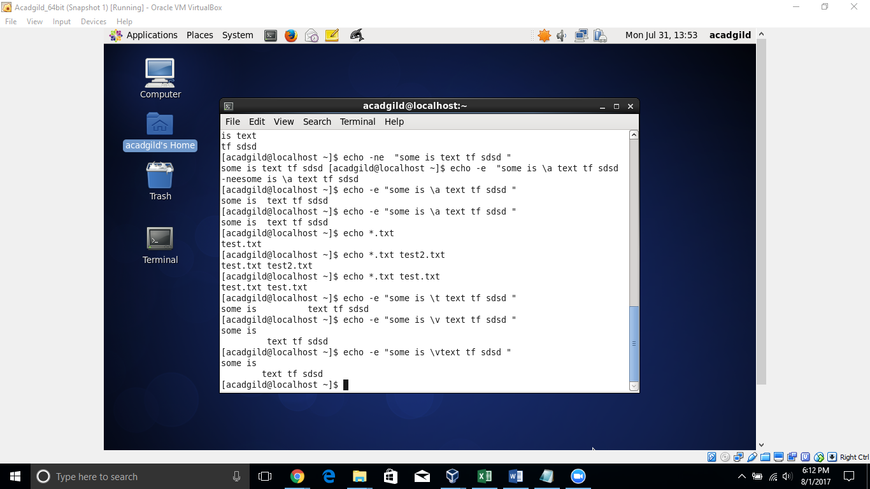

1. **cat:** is nothing but concatenate. It concatenate files content and redirect output to terminal or files.

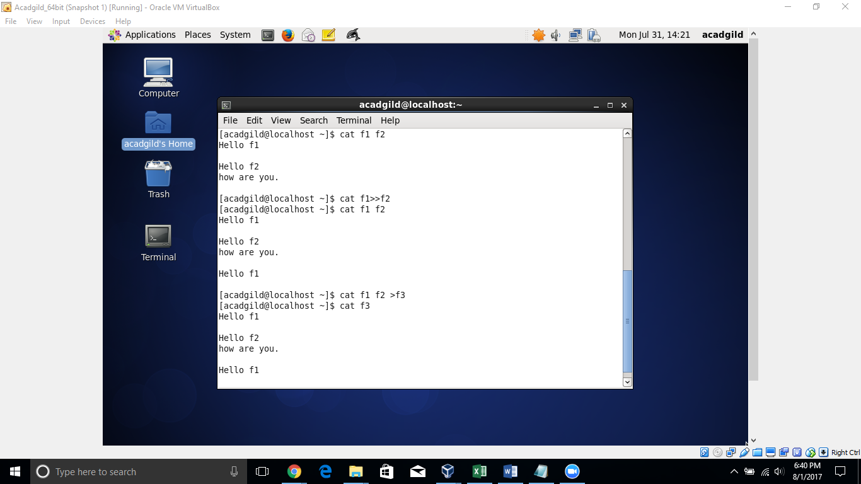

1. **who:** Displays who is on the system

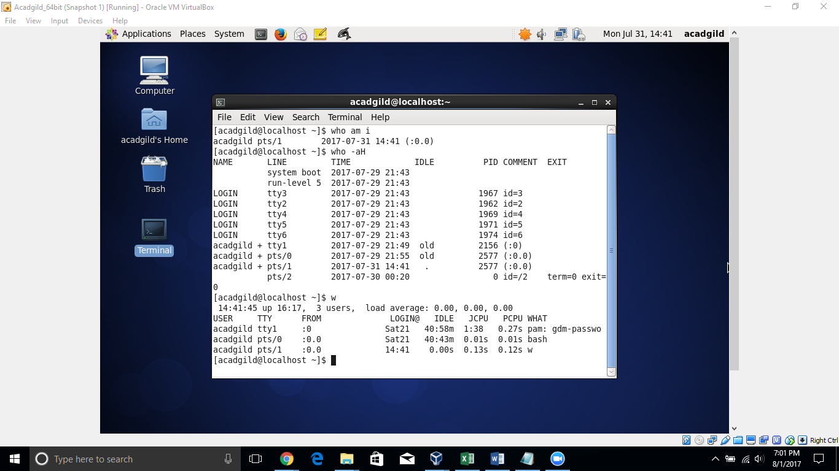

1. **cd:** Move to another directory

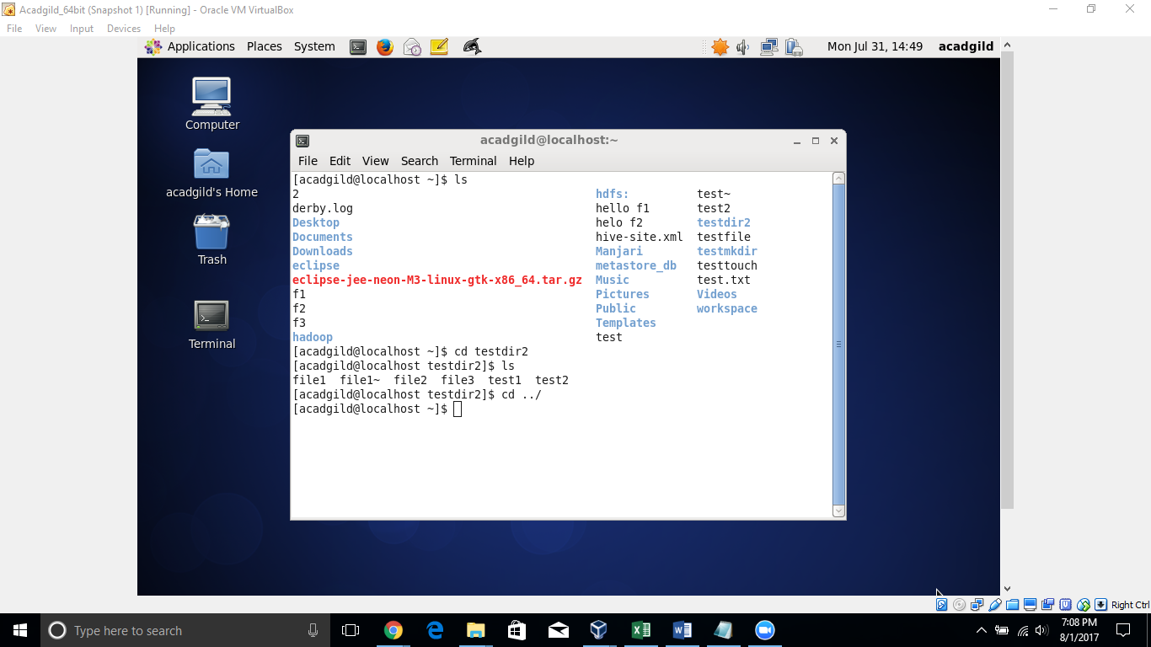

1. **date:** display and set date.

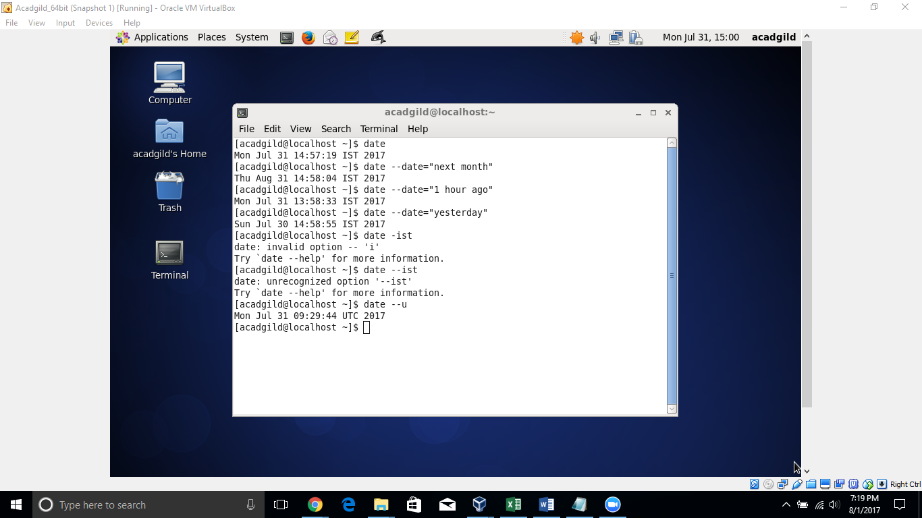

1. **cal:** Display a conveniently-formatted calendar from the command line.

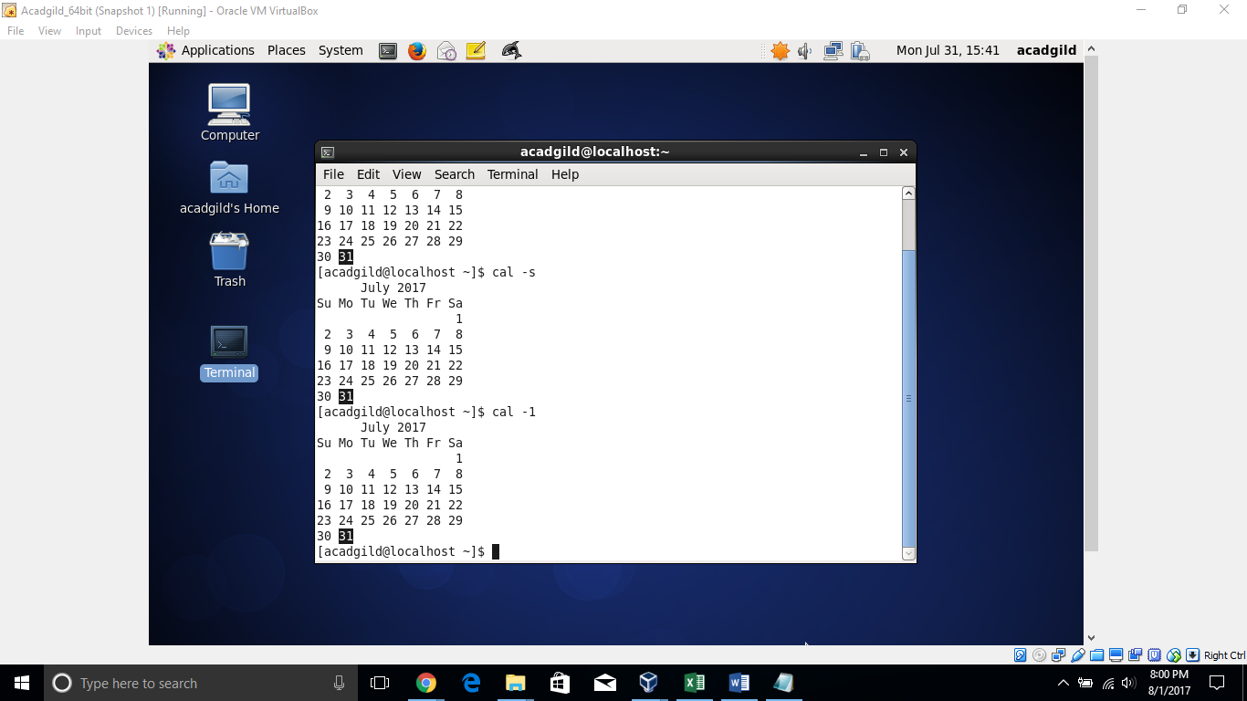

1. **mv:** it’s used to move or rename files. Renames file SOURCE to DEST, or moves the SOURCE file (or files) to DIRECTORY.

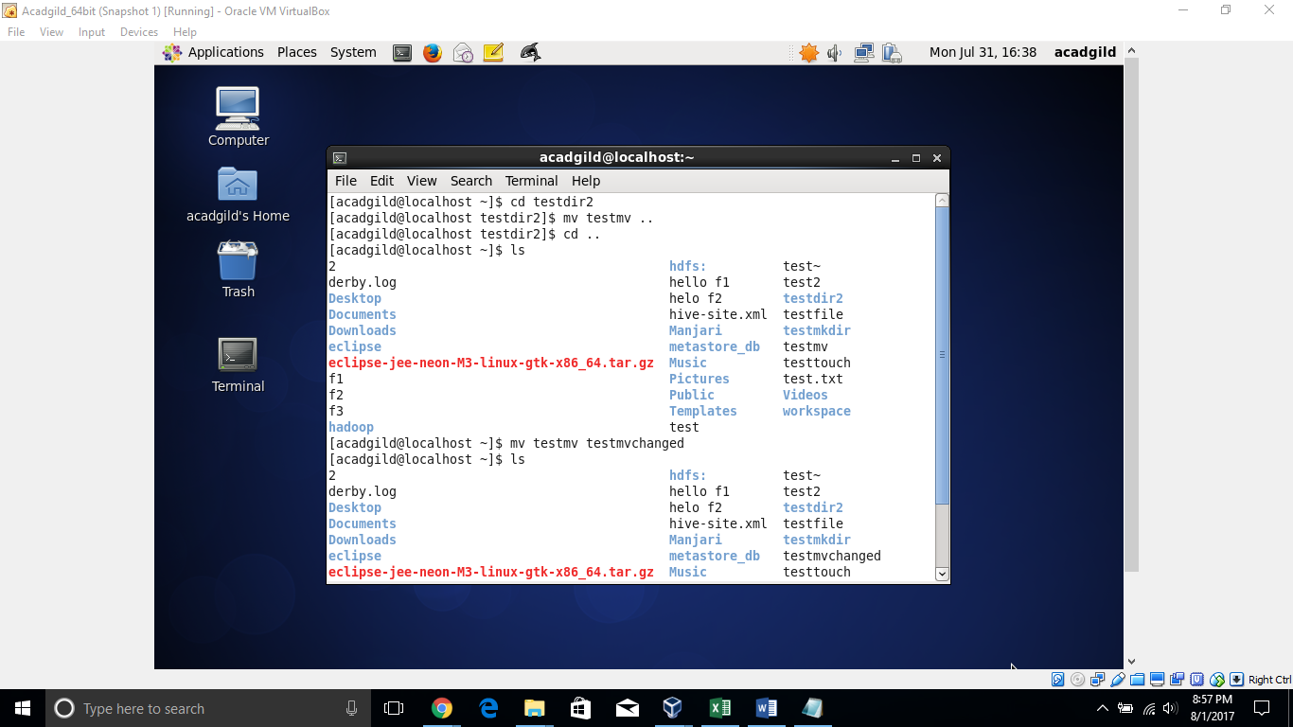

1. **cp:** The cp command is used to make copies of files and directories

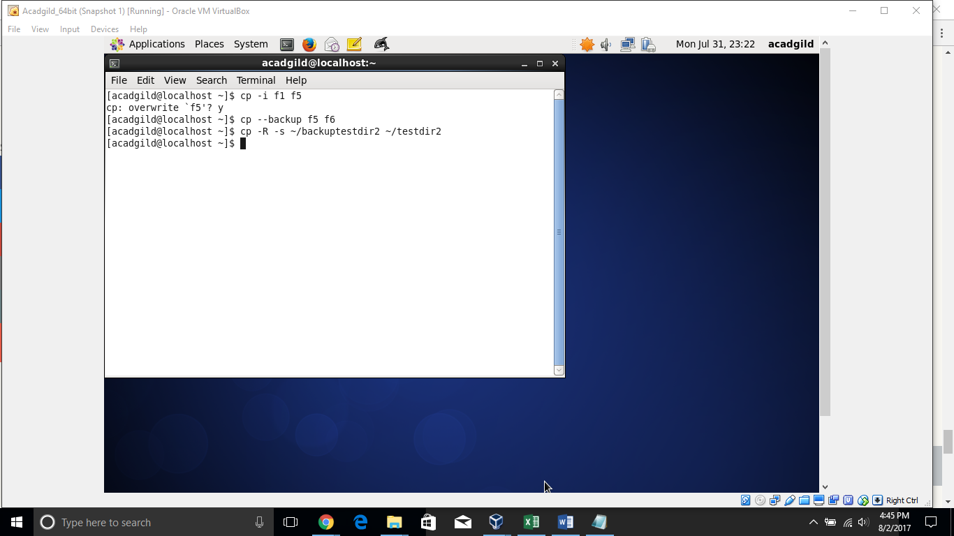

1. **which:** Locate the executable file associated with a given command

